K L UNIVERSITY
FRESHMAN ENGINEERING DEPARTMENT

A Project Based Lab Report On
TITLE OF THE PROJECT : SIMPLE BANKING SYSTEM
SUBMITTED BY:
2500090028 DUDEKULA SIDDARTHA
2500090120 SRINVAS BABU
2500090139 AYUSHMAN MISHRA
2500090183 V.MANOJ KUMAR

UNDER THE GUIDANCE OF

Mr. Sreeram Nimmagadda

Assistant Professor

KL UNIVERSITY
Green fields, Vaddeswaram – 522 502 Guntur Dt., AP, India.

DEPARTMENT OF BASIC ENGINEERING SCIENCES



CERTIFICATE

This is to certify that the project based laboratory report entitled
“SIMPLE BANKING SYSTEM” submitted by Dudekula Siddhartha bearing Regd. No. 25000900028 respestively to the Python Programming, KL University in partial fulfillment of the requirements for the completion of a project in “SIMPLE BANKING SYSTEM” course in I B Tech II Semester, is a bonafide record of the work carried out by us under our supervision during the academic year 2025-26.

Mr. SREERAM NIMMAGADDA Dr. D. HARITHA PROJECT SUPERVISOR HEAD OF THE DEPARTMENT
2500090028 DUDEKULA SIDDARTHA
2500090120 SRINVAS BABU
2500090139 AYUSHMAN MISHRA
2500090183 V.MANOJ KUMAR

ACKNOWLEDGEMENTS

It is great pleasure for me to express my gratitude to our honorable President, Sri. Koneru Satyanarayana, for giving the opportunity and platform with facilities in accomplishing the project-based laboratory report.
We express the sincere gratitude to our director Dr. A Jagadeesh for his administration towards our academic growth.
We express sincere gratitude to our Principal Dr. V Krishna Reddy and HOD-BES1 Dr. D. Haritha for her leadership and constant motivation provided in successful completion of our academic semester. We record it as our privilege to deeply thank for providing us the efficient faculty and facilities to make our ideas into reality.
We express our sincere thanks to our project supervisor Mr. Sreeram Nimmagadda for his novel association of ideas, encouragement, appreciation, and intellectual zeal which motivated us to venture this project successfully.
Finally, We are pleased to acknowledge the indebtedness to all those who devoted themselves directly or indirectly to make this project report success.

ABSTRACT

The Simple Banking System is a basic console-based application developed using Python that simulates essential banking operations. The system allows users to create accounts, securely log in using an account number and PIN, and perform core banking activities such as checking balance, depositing money, withdrawing funds, and transferring money between accounts.
The application maintains user account details in a structured format using dictionaries, ensuring efficient data handling during execution. It emphasizes fundamental programming concepts including functions, conditional statements, loops, and data structures. Basic validation is implemented to handle incorrect inputs and insufficient balance scenarios, ensuring reliability and user-friendly interaction.
This project serves as an introductory model for understanding how banking systems operate digitally. It demonstrates the core functionalities of financial transactions in a simplified manner and can be further enhanced with features like data persistence, encryption, and graphical user interfaces.

INDEX

S.NO | TITLE | PAGE NO
1 | Introduction | 6
2 | Aim of the Project | 7
2.1 | Advantages & Disadvantages | 8
2.2 | Future Implementation | 8
3 | Software & Hardware Details | 9
4 | Flow Chart | 10
5 | Algorithm for each module | 11
6 | Implementation | 12
7 | Output/ Screen shots | 13
8 | Conclusion | 14

INTRODUCTION

Simple Banking System – Project Introduction
The Simple Banking System is a Python-based application developed to mimic the fundamental operations of a real-world banking system in a streamlined and accessible way. The primary goal of this project is to demonstrate how basic programming concepts can be applied to create a functional and interactive system that manages financial transactions and user data efficiently.
This system enables users to perform key banking activities such as creating an account, depositing money, withdrawing funds, and checking account balances. Each operation is designed to reflect real-life banking processes, helping users understand how transactions are handled securely and accurately. The application ensures that all actions are processed logically, maintaining consistency in account data throughout its usage. The project is built using core Python concepts including functions, loops, conditional statements, and data structures such as lists or dictionaries. These elements work together to create a structured and organized flow, making the system easy to understand, modify, and expand. Error handling and input validation are also incorporated to enhance reliability and prevent invalid operations, highlighting the importance of accuracy in financial systems.
Beyond its technical implementation, the Simple Banking System helps in developing essential skills such as problem-solving, logical reasoning, and program design. It serves as a stepping stone toward more advanced projects, including database-driven applications and full-stack banking solutions. By working on this project, learners gain confidence in translating theoretical knowledge into practical applications.
"Turning code into currency — where every line builds a smarter, faster, and more reliable banking experience."
In conclusion, the Simple Banking System is not just a coding project, but a practical demonstration of how Python can be used to build efficient, secure, and user-oriented applications that solve real-world problems.

AIM

The aim of this program is to develop a Simple Banking System using Python that allows users to perform basic banking operations such as account creation, secure login using a PIN, checking account balance, depositing money, withdrawing funds, and transferring money between accounts.
The program is designed to demonstrate the use of fundamental programming concepts like functions, loops, conditional statements, and data structures (dictionaries) while providing a simple and interactive user experience.

ADVANTAGES
- Advantages of Simple Banking System
- User-Friendly Interface
- The program uses a simple menu-driven approach, making it easy for users to understand and operate.
- Basic Banking Operations
- Supports essential functions like balance checking, deposit, withdrawal, and fund transfer.
- Secure Login System
- Uses account number and PIN for authentication, providing basic security.
- Efficient Data Management
- Stores account details using dictionaries, allowing quick access and updates.
- Time Saving
- Users can perform transactions instantly without manual calculations.
- Error Handling
- Prevents invalid operations such as negative deposits or withdrawing more than available balance.
- Expandable Design
- The system can be easily improved by adding features like database storage, GUI, or encryption.
- Learning Purpose
- Helps beginners understand programming concepts like functions, loops, conditions, and data structures.
- No External Requirements
- Runs using basic Python without needing additional software or libraries.
- Multi-User Support (Basic)

DISADVANTAGES

- Disadvantages of Simple Banking System
- No Data Persistence
- All account data is stored in memory (dictionary). Once the program stops, all data is lost.
- Weak Security
- PINs are stored in plain text and there is no encryption, making it insecure.
- No Input Validation for Errors
- The program may crash if the user enters non-numeric values (e.g., letters instead of numbers).
- Limited Functionality
- Does not include advanced banking features like transaction history, interest calculation, or account deletion.
- No Database Integration
- Uses only in-program storage instead of a real database like MySQL or SQLite.
- Single User at a Time
- Cannot handle multiple users simultaneously (no concurrency or multi-threading).
- No Graphical User Interface (GUI)
- Runs only on the console, which is less attractive and user-friendly compared to modern apps.
- No Authentication Limits
- Allows unlimited login attempts, making it vulnerable to brute-force attacks.
- No Backup or Recovery System
- If the system fails, there is no way to recover lost data.
- No Transaction Loggig

SYSTEM REQUIREMENTS

SOFTWARE REQUIREMENTS:
The major software requirements of the project are as follows: Language: PyCharm
Operating system: Windows 10 or more.
Technical requirements: Monitor, CPU, Keyboard, Mouse, etc.

HARDWARE REQUIREMENTS:
The hardware requirements that map towards the software are as follows: RAM: 2 GB.
Processor: i3


Flow Chart

+ +

| User |
+ +
|
-----------------------------------------
| | | |

v v v v
+------------+ +------------+ +------------+ + +

| Login | | Deposit | | Withdraw | | Transfer |
+------------+ +------------+ +------------+ + +
| | | |
-------------------------------------------

| v
+ +

| Accounts Data |
| (Dictionary) |
+ +
^
|
+ +

| Create Account|
+ +

| v
+ +

| User |
` + +

ALGORITHM
Algorithm: Simple Banking System
Step 1: Start

Step 2: Initialize the system with predefined accounts (account number, name, balance, PIN).

Step 3: Display main menu:
Login
Create Account Exit
Step 4: Read user choice.

If choice = 2 (Create Account): Generate a new account number. Input user name.
Input PIN.
Input initial deposit amount. Store details in accounts database.
Display account creation success message. Go back to main menu.
If choice = 1 (Login):
Input account number and PIN.
Check if account exists and PIN is correct.
If valid → Login successful.
Else → Display error and return to main menu. After Successful Login:
Step 5: Display operations menu: Check Balance
Deposit Withdraw
Transfer Logout

Step 6: Read user option.

If option = 1 (Check Balance):
Display current balance. If option = 2 (Deposit):
Input deposit amount.
If amount > 0 → Add to balance. Display updated balance.
Else → Show invalid amount message. If option = 3 (Withdraw):
Input withdrawal amount.
If amount ≤ 0 → Show error.
Else if amount > balance → Show insufficient balance. Else → Deduct amount and display remaining balance. If option = 4 (Transfer):
Input receiver account number. Check if receiver exists.
If not → Show error.
Input transfer amount.
If amount > balance → Show insufficient balance.
Else → Deduct from sender and add to receiver.
Display success message. If option = 0 (Logout): Logout user.
Return to main menu. If choice = 0 (Exit):
Display goodbye message. Stop the program.
Step 7: End

IMPLEMENTATION

# SIMPLE BANKING SYSTEM

accounts = {
"1001": {"name": "Ravi", "balance": 5000, "pin": "1234"},
"1002": {"name": "Priya", "balance": 8000, "pin": "5678"},
}

def login():
acc_no = input("Account Number: ") pin = input("PIN: ")
if acc_no in accounts and accounts[acc_no]["pin"] == pin: print(f"\n Welcome, {accounts[acc_no]['name']}!") return acc_no
print("Wrong account number or PIN!") return None
def show_balance(acc_no):
print(f" Balance: Rs.{accounts[acc_no]['balance']}")

def deposit(acc_no):
amount = int(input("Deposit amount: Rs.")) if amount > 0:
accounts[acc_no]["balance"] += amount
print(f" Rs.{amount} deposited! New Balance: Rs.{accounts[acc_no]['balance']}") else:
print("Enter a valid amount.")

def withdraw(acc_no):
amount = int(input("Withdraw amount: Rs.")) if amount <= 0:
print("Enter a valid amount.")
elif amount > accounts[acc_no]["balance"]:
print(f"Not enough balance! You have Rs.{accounts[acc_no]['balance']}") else:
accounts[acc_no]["balance"] -= amount
print(f" Rs.{amount} withdrawn! Remaining: Rs.{accounts[acc_no]['balance']}")

def transfer(acc_no):
to = input("Transfer to Account Number: ") if to not in accounts:
print("Account not found!") return
amount = int(input("Amount to transfer: Rs.")) if amount > accounts[acc_no]["balance"]:
print("Not enough balance!") else:
accounts[acc_no]["balance"] -= amount

accounts[to]["balance"] += amount
print(f" Rs.{amount} sent to {accounts[to]['name']}!")

def create_account():
acc_no = str(1000 + len(accounts) + 1) name = input("Your Name: ")
pin = input("Set a 4-digit PIN: ")
dep = int(input("Opening Deposit: Rs."))
accounts[acc_no] = {"name": name, "balance": dep, "pin": pin} print(f" Account created! Your Account Number: {acc_no}")

# ── Main Program ──────────────────────────────
print("=" * 35)
print(" SIMPLE BANKING SYSTEM")
print("=" * 35)
while True:
print("\n1. Login\n2. Create Account\n0. Exit") choice = input("Choose: ")
if choice == "0": print("Goodbye!") break

elif choice == "2": create_account()

elif choice == "1": acc = login()
if acc:
while True:
print("\n1.Balance 2.Deposit 3.Withdraw 4.Transfer 0.Logout") ch = input("Choose: ")
if ch == "1": show_balance(acc) elif ch == "2": deposit(acc)
elif ch == "3": withdraw(acc) elif ch == "4": transfer(acc)
elif ch == "0": print("Logged out."); break else: print("Invalid choice.")

OUTPUTS

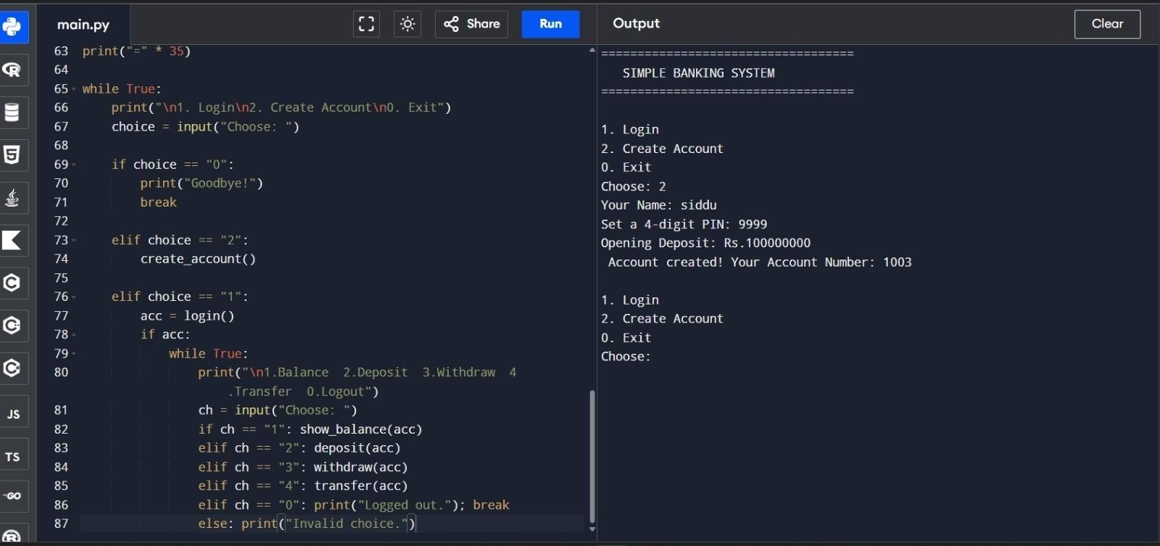
Screen Shot:

Conclusion

The Simple Banking System project demonstrates how basic banking operations such as account creation, deposit, withdrawal, and balance inquiry can be implemented using Python. Through this project, we applied core programming concepts like functions, conditionals, loops, and data structures to simulate real-world banking activities.
This project helps in understanding how user input is handled, how data is stored and updated, and how logical flow controls the system’s behavior. Although it is a basic model, it provides a strong foundation for building more advanced banking applications with features like databases, security, and graphical interfaces.
Overall, the project highlights the practical use of Python in developing real-life applications and improves problem-solving and programming skills.

